DOCTOR REVEALS Top Foods To Eat To HEAL THE BODY & FIGHT DISEASE! | Dr. William Li

Korte presentatie 23 februari 2022 door Donaat Vernieuwe

https://www.youtube.com/watch?v=LGVksgBo30c

Engels automatisch gegenereerde ondertitels.

Op 13’20”:

Clinical trial: 30.000 men followed over 20 years. Men who ate 1 to 1 ½ cup of cooked tomatoes lowered the risk of prostate cancer with 29%.

The more tomato sauce, the less aggressive the cancer in men who developed prostate cancer already.

Even for women there was a 20% lowering of the risk of breast cancer.

The lycopene in tomatoes prevents also macular degeneration of the eye.

Not only tomatoes prevents but also carotenoids like carrots, red peppers….(Carotenoids are yellow, orange, and red pigments synthesized by plants).

Op 21.45: Beans, tree nuts, olive oil has cancer starving properties, also dried spices.

AVOID:

Red meat, artificial processed meat (mass produced stuff), other ultra processed food, sugar and artificial sweeteners, white bread….

Op 30min:

Dark chocolate for heart disease

2 cups/day after 30 days: number of stem cells x2 + improvement of blood flow

43’30” Mushrooms and tree nuts prevention of cancer

44’30” Stage 3 colon cancer: 2 handful of tree nuts decreases 50% in mortality

45’ Arcomania bacteria – pomegranate juice, cranberries and conquering grapes. Success with immune therapy 100% instead of 20%. Lowers risk of cancer.

Natto: fermented soybeans. Starves cancer.

Nattō (納豆), spelled as natto in standard English language use, is a traditional Japanese food made from whole soybeans that have been fermented with Bacillus subtilis var. natto.^{[1]} It is often served as a breakfast food, and often with rice.[

Other fermented foods: yogurt, kimchi

Kimchi, is a traditional Korean side dish of salted and fermented vegetables, such as napa cabbage and Korean radish. A wide selection of seasonings are used, including gochugaru, spring onions, garlic, ginger, and jeotgal, etc. Kimchi is also used in a variety of soups and stews.

56’: Green tea prevents all sorts of cancers

Tomato (prepared) for prostate cancer

Phytonutrient green vegatables – Kale

Seafood, salmon, shell fish, sea bass…

1u06’ Turning down inflammation: green tea, vitamin C, strawberries, red peppers, tomatoes, oranges….

1u10’ Fish oil anti inflammation, sea bass..

STOP 1u. 13’

Samengevat: prevents cancer, stops cancer:
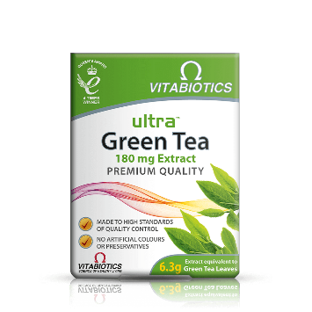
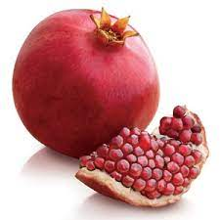

Green tea

Pomegranate juice, especially with immune therapy
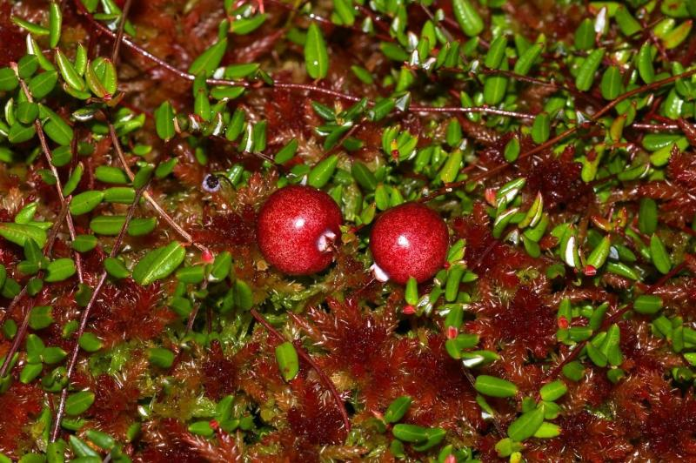
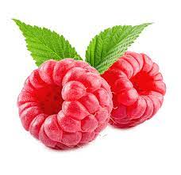
Raspberries Cranberries

Conquering grapes
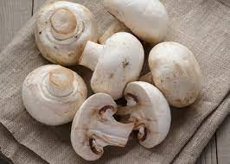
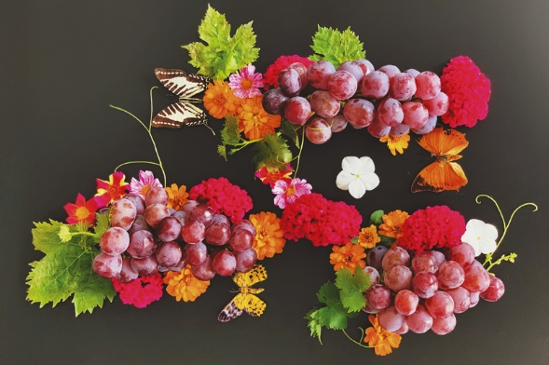
Mushrooms

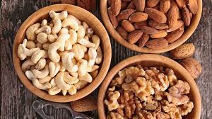
Tree nuts (walnuts....)

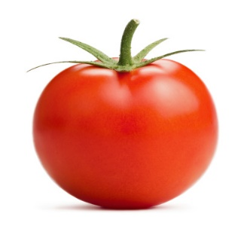
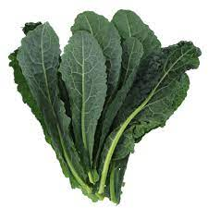
Green and dark green
leafy vegetables
like kale Tomatoes
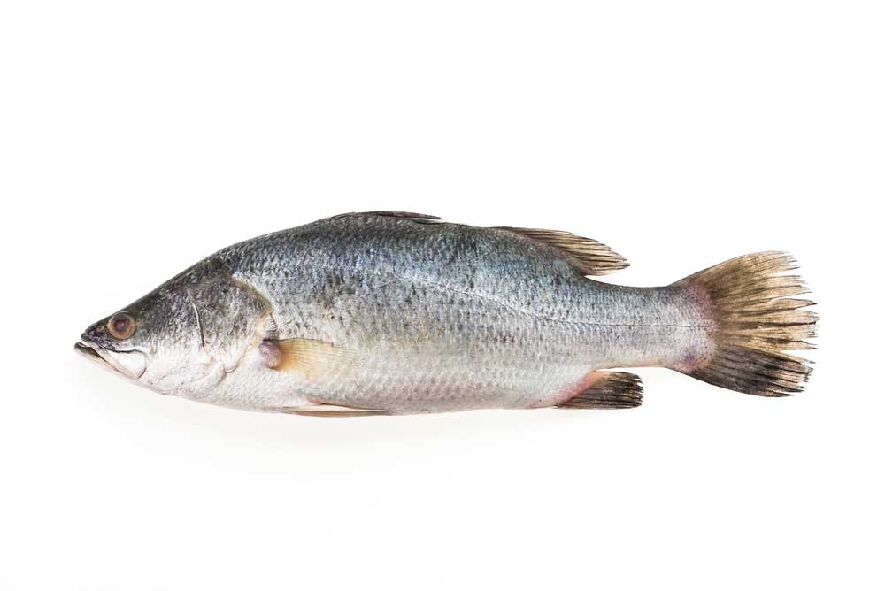
Seafood: Salmon, shell fish, sea bass
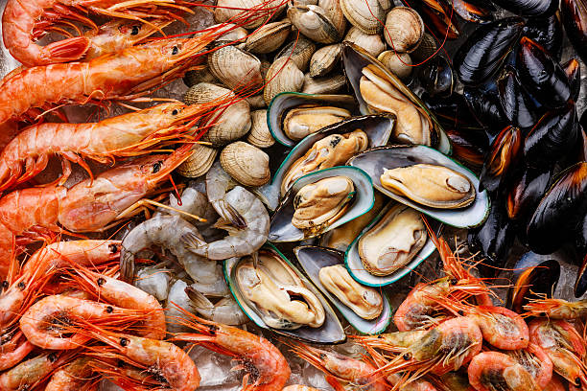
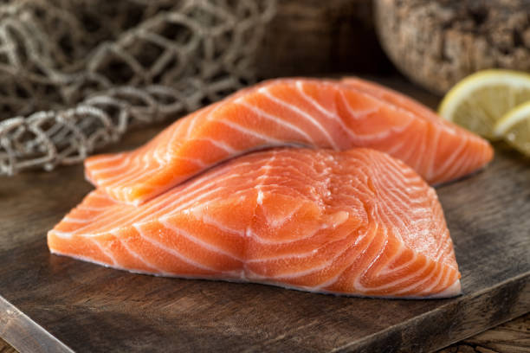

Fermented foods:
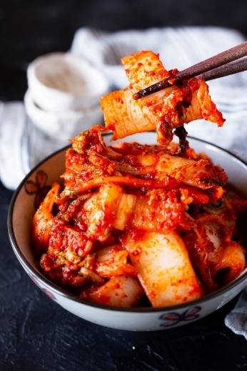
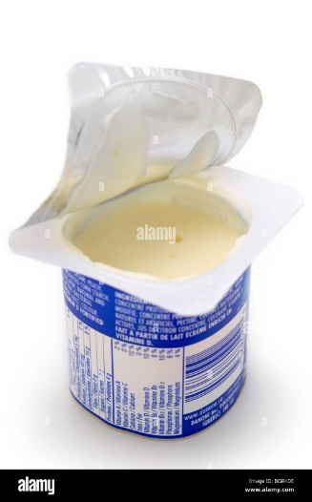
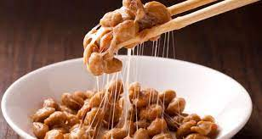
Natto (fermented soy beans) Yogourt Kimchi

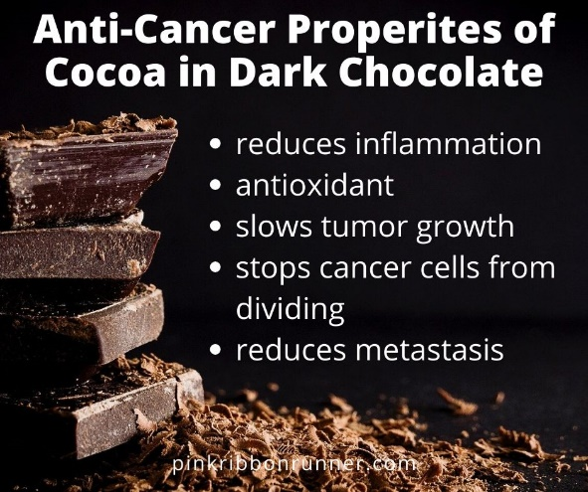
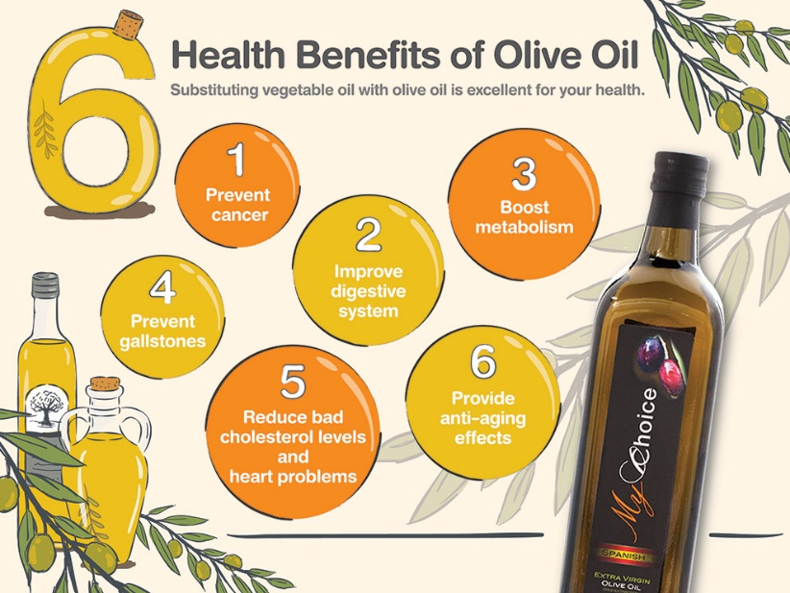
Olive oil Dark Chocolate

