Presentatie over dementie en alzheimer
Woensdag 10 november 2021 Donaat Vernieuwe

Wat is het verschil tussen dementie en alzheimer
https://www.vegro.nl/advies/zelfredzaamheid/verschil-dementie-en-alzheimer#gref
Bij iemand met dementie kunnen de hersenen informatie niet goed meer verwerken.
Alzheimer is een vorm van dementie.

Google: What percent of 80 year olds have Alzheimer's?
Age is the greatest of these three risk factors. As noted in the Prevalence section, the percentage of people with Alzheimer's dementia increases dramatically with age: 3% of people age 65-74, 17% of people age 75-84 and 32% of people age 85 or older have Alzheimer's dementia.Mar 10, 2563 BE

- 10 Warning Signs You Already Have Dementia 22 min.
Nederlandse ondertitels https://youtu.be/Cd3u0yav_bU

Van 0 tot 09’00
Types of dementia – Early detection and prevention (reversable?) - Tolerance – Stages – Detection: poisture and movement - Causes of dementia – Use it or loose it: fuel – stimulation …. Excerise!
Stages:
- Normal
- Very mild decline Forgets occasionally
- Early stage dementia Forget names, what you just read/did
- Moderate decline Simple math 100 -7 -7 -7 Planning
- Mid stage dementia Moderate/severe decline

Signs of the early stages:
- Tremor
- Smaller handwriting
- Smell capacity lowers
- Sleep quality lowers
- Hunched poister
- Loss of armswing
When you pay attention to poisture and armswing: you’ll reinforcing brainfunction.

When do we have to worry?
Dementia Normal with age
Chronic poor judgement Occasional bad choices
Unable to manage a budget Now and then missing a bill
Loosing track of date, time, season Forgetting which day it is
Loosing things, unable to retrace steps Loosing things time to time
Difficulty being coherent (structure, reasoning) Sometimes searching a word

From 14’58” to end (starts with Biden)
- Mid to late stage dementia Can’t recall spouse name……
- Late stage dementia
Reversable until stage 3….

- Early detection of Alzheimer's disease: Elli Kaplan at TEDxPeachtree 2012
https://youtu.be/b6fnQ7gYol0
Van 4’38” tot 7’27”: 3 min English generated
Oogbewegingen, aandacht voor beelden. 100% zekerheid!

- UF researchers find that 'peanut butter' test can help diagnose Alzheimer's disease 02’00” English generated
https://youtu.be/z1mcAAgrCnw
Info van Danny van het BPH: in het BPH doen ze lichamelijke en psychologische testen om Alzheimer vast te stellen. Een opvolging daarvan kan een MRI scan zijn.

- There Is Some Hope For Those With Alzheimer's Disease
https://youtu.be/MxuGJZDnMuU
Vanaf halfweg interessant. 3’43” – 7’20” : 4 min. English generated
Mind diet: berries, green vegetables and less animal fat: cognitive decline 7,5 year younger (2015)
Other study: 1 or 2 servings of green vegetables per day: 11 year younger in age.
Medication Aricept… side effects…
Supplements 200mg vitamin E, 300mg vit.C + beta carotine (red orange pigment in fruits and vegetables like carrots but also onions, is converted in the body in vit.A).

Aricept is één van de medicamenten die ze volgens Danny in het BPH succesvol toedienen.
Van Google:
What does Aricept do to the brain?
Aricept (donepezil) improves the function of nerve cells in the brain. It works by preventing the breakdown of a chemical called acetylcholine (ah SEET il KOE leen). People with dementia usually have lower levels of this chemical, which is important for the processes of memory, thinking, and reasoning. Feb 1, 2564 BE

- Here's how patients say they reversed early Alzheimer's symptoms

3 min. English generated
https://www.youtube.com/watch?v=YHVgpRbukjc

- What 2 Servings Of Mushrooms A Week Does To The Brain! 3 min.
English generated
https://youtu.be/WvAI3mtFImY

What you can do to prevent Alzheimer's | Lisa Genova Nederlandse ondertiteling https://youtu.be/twG4mr6Jov0

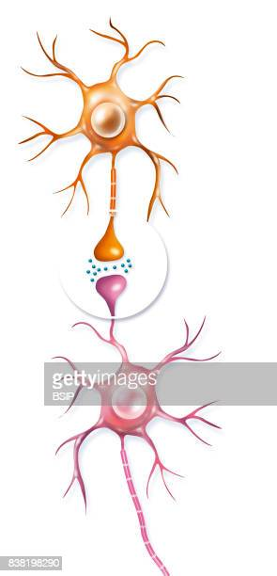
Neuron Neuron

Synaps

7’20” tot einde 14’ : 7 min.

Ons DNA bepaalt niet alleen of we Alzheimer krijgen.

Preventie punten:

Goede slaap

Lichaamsbeweging

Dieet

Iets compleet nieuws leren

Extra’s:

What Eating Just 1 Mushroom A Day Does To Cancer Risk!
https://www.youtube.com/watch?v=DUvri4X6i2I

"Benefits of Blueberries for the Brain
https://youtu.be/xdjtf1oXypo

9 Foods To Eat Every Day To Protect The Brain From Alzheimer's & Dementia! The Neuro9

https://youtu.be/pRlSG1Jm_O0

